# Networks Essentials

## Cisco Packet Tracer:

### Icons:

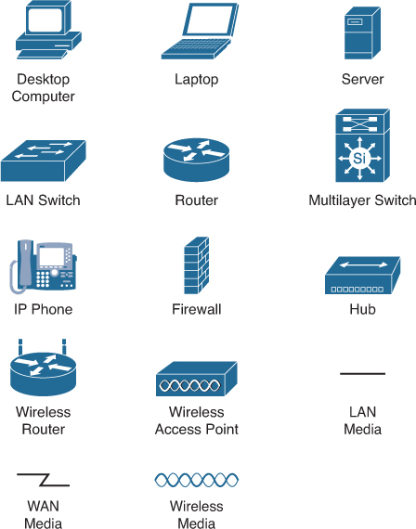

### Topology (how is the network represented):

* Physical: physically visible (connected through wires etc. 🡺Packet tracer)
* Logical: IP-adresses, IPV4, IPV6 etc.

### Packet tracer videos:

* 02
* 06: demo opstelling
* 07
* 08
* 14: vid 2

## Module 1: Networking today

### Types of networks:

* Small home network (soho = Small office small home)
* Medium to large Networks
* Worldwide network

### Network components:

* End device:
  + Phone
  + Laptop
  + PC
* Intermediary device:
  + Diagram

    Description automatically generatedConnect other things to the network
  + Switch
  + Router
* Network media:
  + Transmitting data
  + Wired cables
    - Copper
    - Fiber optic
  + Wireless
* Clients & servers:
  + Client 🡪 request information
  + Server 🡪 providing information
* Peer to peer:
  + Computers can be both client en server
  + Advantages:
    - Easy to set up
    - Less complex
    - Low cost
    - Used for simple tasks
  + Disadvantage:
    - Not secure
    - No scalability

### LAN, WAN & Internet:

#### LAN:

Local Area Network.

Most of the time all of the PC’s are able to see eachother.

* Home-networks
* School

#### WAN:

Wide Area Network.

Basically connecting LAN’s together.

* City-networks
* Large campus networks

#### The internet:

Large collection of interconnected WAN’s

* Intranet: Local internet for a company only
  + No one outside company can access
* Extranet: Company and suppliers can acces this.
  + Not open to public
  + Portal to login to a certain network
* Internet: Open and used for/by everyone.
* Darkweb: special spot for special people.

#### Converging networks:

Earlier there were 3 types of networks. Nowadays these networks are converged together.

### Four basic Characteristics of a network:

* Fault tolerance: Not failing or there’s a backup
* Scalability: Upgrade the network without changing too much.
* Quality of service: Consistent speed and bandwith.
* Security: Everything needs to be secure. (logins etc)

### Network trends:

* Smart technology
* Bring your own device
* Online collabs
* Video conferences
* Cloud computing

### Types of networks:

* Powerline networking: Using electrical wiring to connect devices
* Wireless Broadband: Antenna on house to connect to the internet.

## Module 2: Sections & objectives

### Cisco IOS:

Operating system that allows users to interact with a system device.

* Shell: User interface that allows the user to request specific tasks from the computer. (CLI or GUI)
* Kernel: communicates between hardware. Manages hardware resources

### Connecting to a cisco device:

* Console: physical connection through cable (laptop – cisco device 🡪 initial instalation).
* Secured shell (ssh): Secure remote connetion to a device through a virtual interface.
  + This virtual interface is a program like PUTTY.
* Telnet: insecure remote connection.
* Configuration is done through cli commands.

### Types of configuration modes:

#### User EXEC Mode:

* > sign!!!!
* Limited number of basic commands

#### Privileged EXEC Mode:

* # sign!!!!
* Acces to all commands

#### Global configuration mode:

* Used to access configuration options in the device
* Bv: Switch(config)#

#### Line configuration mode:

* Configuring console/SSH/telnet/AUX access
* Bv: Switch(config-line)#

#### Interface configuration mode:

* Configuring switch port or router interface
* Bv: Switch(config-if)#

### Basic IOS command structure:

You can use shortcuts for certain commands. (example: configuration terminal 🡪 config t)

### Configure passwords:

In line console configuration 🡪 password thepasswordyouwant 🡪 login

In config t 🡪 enable secret password

### Banner message:

Warning for unauthorized personnel.

* Banner motd #message#

## Module 3: Network protocols & communications

### Communication fundamentals:

* Sender = source
* Receiver = destination
* Medium/media = path of communication (wifi,cable,…)

### Communication protocols:

Rules the communication will folow:

* An identified sender & receiver
* Common language and grammar
* Speed and timing of delivery
* Conformation of receivement

Computer communication protocols:

* Message encoding
* Message formatting and encapsulation
* Delivery options
* Agreed-upon protocols

### Message encoding:

The process of converting information into another form of acceptable transmission. Decoding reverses this process.

It’s important that the receiver is able to decode the message.

### Message delivery options:

* Unicast: 1 to 1 communication
* Multicast: 1 to many
* Broadcast: 1 to all

### Protocol suites:

#### Internet Protocol suite (TCP/IP):

Most common protocol suite, maintained by IETF

Most companies now use TCP/IP

#### Open systems interconnection (OSI):

Link to OSI model

#### Apple talk:

Only apple

### Graphical user interface, application Description automatically generatedTCP/IP protocol suite:

Application layer:

applications that do requests.

Transport layer:

- TCP: packets are getting checked if they are fully complete and working

- UDP: Just accepts every packet. Working or not.

Internet layer:

- IP adresses and routing

### Internet standards:

Instances that look into new standards or functions that need to be added so communication between all devices is possible.

### The benefits of using a layered model:

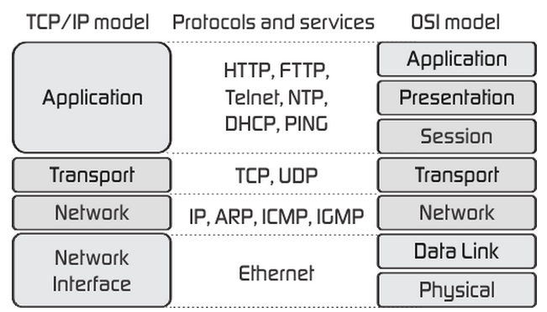Easier to explain the complex concepts such as how a network operates and such.

Examples:

* OSI: 7 layers
* TCP/IP: 4 layers

OSI:

* Physical : Medium
* Datalink: MAC adresses
* Network: IP adresses
* Transport: dataflow reliable?
* Session : TLS/SSL
* Presentation: how does it need to be presented
* Application: DNS/HTTP

### Data encapsulation:

#### Segmenting:

Breaking up a message into smaller units.

* Increases speed
* Increases efficiency: if there is a problem with sending they will only need a small unit to be sent again.

#### Multiplexing:

Data tussen elkaar in zetten.

### Protocol data units (PDU):

How a packet looks on every layer of the OSI or TCP/IP model.

* Physical layer: bits
* Data link layer: Frames
* Network layer: packets
* Transport layer: TCP segments / UDP datagrams
* Application layer: data

## Module 4: Physical layer

A physical layer transports bits across the media. It accepts a complete frame from the data linky layer and encodes it as a series of signals, it will then encapsulate this and send it away. It’s also able to accept bits from other devices and de-encapsulates it to frames.

### Bandwidth:

The capacity of a line you should reach.

#### Throughput:

The effective capacity of a line.

#### Goodput:

Effective data transfer withing a line. (Not source & destination etc.)

#### Latency:

Effective time data needs to travel between 2 points.

### Chart, histogram Description automatically generatedCables:

#### Copper cables:

* Twisted pair:
  + Filter away interference
  + 2 twisted wires
  + Shielding : aluminum shield around the wire
* Coax:
  + Shielded aswell
* Downsides:
  + Electromagnetic interference (generators etc)
  + Radiofrequence interference
* Positives:
  + Cheap
  + Easy to use
* Categories:
  + High categories have higher speeds (UTP)

#### Fiber optic cables:

Wires way thinner than copper and more flexible.

No electromagnetic interference, signals drag way further than copper so very usefull on big appartment buildings and for long distance .

Doesn’t transport electricity!

Fiber is faster atm.

#### Wireless media:

## Module 5: Number systems

Just recap binary – decimal – hexadecimal

## Number 6: Data Link layer

Network card, uses the IP protocol for communication. Gives source en destination MAC adress. Also checks if the packets are valid or if there’s something wrong.

Use of NIC: reforming electrical signals to digital information stream.

### Topology:

**Physical topology:** fysical place in the network (example: rack 2 shelf 1)

**Logical topology:** Logical place in the network (example: ethernet port x )

### WAN topology’s:

* Point-to-point: permanent link between 2 endpoints.
* Hub and spoke: central site interconnects branch sites through point to point.
* Mesh: Every end system is connected to every other end system.

### LAN topology’s:

Bus and ring topology’s arent’t used alot these days.

The star and extended star are connected to a switch in the middle.

### Duplex communication:

#### Half-duplex:

Only one device allowed to send information at a time.

#### Full-duplex:

Both devices are allowed to send information at the same time.

### Chart, funnel chart Description automatically generatedThe frame:

* Header
* Data
* Trailer

### Layer 2 addresses:

Physical address. Part of the header in the frame ‘addressing’.

## Module 7: Ethernet switching

Just talks about ethernet encapsulation.

## Module 8: Network layer

The network layer performs 4 basic operations:

* Addressing end devices
* Encapsulation
* Routing
* De-encapsulation

### Characteristic of IP:

* Connectionless:
  + No connection with destination before sending packet
  + No control information needed
  + No pre-notifications that there’s anything coming
* Best effort:
  + Ip will not garuantee delivery
  + No acknowledgements
  + Does not know if it’s received or if the receiver is online
* Media independent:
  + Cannot fix undelivered packets
  + Cannot retransmit
  + Must rely on other protocol for certain functions

## Module 9: adress resolution

Arp explained. See PT video on BB.

## Module 10: Basic Router Configuration

### Router config:

### Router interface config:

### Checking interface config:

### Configure default gate-way:

Ip default-gateway “123.168.1.1”

## A screenshot of a computer Description automatically generated with low confidenceModule 7: IPv4 adressing

### IPv4 address structure:

32-bit

#### Network portion & host portion:

Determined by a subnetmask

#### Prefixes:

Counting 1’s

The total amount of IP addresses is always -2: network & broadcast address

## A screenshot of a computer Description automatically generated with low confidenceModule 11: IPv4 Adressing

### Over het IPv4 adres:

* 32 bit groot
  + 4x 8 bits

### Subnetting:

1. What is your ip,subnetmask/prefix (Write down).
2. Table

   Description automatically generatedWrite down subnetmask (all the 1).
   1. Length of 4x8bits
3. Write down IP adress.
4. Draw a line after the last 1 of the subnetmask straight down.
5. Write down Netw & broadcast. 🡪 behind line
   1. Network == all 0
   2. Broadcast == all 1
6. Calculate amount of hosts

Submask == waarde van de eentjes (binair gezien)

### Private and public addresses:

Introduced because there are not enough IPv4 addresses.

### Classfull addressing:

### VLSM:

Dividing hosts over a network.

??????????????

### Configureren in PT:

* Host info invullen bij ip configuration

## Module 12: IPv6 addressing

IPv4 is limited in its possibilities.

For example: Amount of IPv4 is limited

### IPv6 address representation:

* 128bits in length
* x:x:x:x:x:x:x:x
* Exists out of hexadecimals
* You can leave out leading 0’s
* If 0000 🡪::

### IPv6 uni, multi & anycast:

* Uni: 1 to 1
* Multi: 1 single IPv6 packet send to multiple destinations
* Any: A V6 unicast address that can be assigned to multiple devices. A packet sent to an anycast address is routed to the nearest device having that address.

A IPv6 address doesn’t have a broadcast address.

### IPv6 prefix:

From 0-128 prefixlength. Most of are is /64.

### IPv6 unicast addresses:

#### Global unicast:

Globally unique public addresses

#### Link-local (FE80):

Used locally on a single network.

#### Unique Local:

Used for local addressing within a site.

#### Loopback (127)

## Module 13: ICMP

Provides feedback about issues related to the processing of IP packets.

* Host reachability
* Destination or service unreachable
* Time exceeded

### ICMP echo:

* Local host sends ICMP echo to destination host
* If there, destination host replies with an echo reply

### ICMP unreachable:

## Module 14: Transport layer

### Role of the transport layer:

Temporary communication session between two applications and delivering data between them. It is also a link between the application layer and the lower layers that are responsible for network transmission.

### Responsibilities:

* Tracking the conversation:
  + Tracks each individual conversation flowing between source end destination.
* Segmentation:
  + Divides the data into segments that are easier to manage and transport.
* Identifying:
  + Ensures that with even multiple applications running on a device. All the applications receive the correct data via portnumbers.

### TCP/UDP:

#### UDP:

* Fast
* Low overhead
* Does not require acknowledgement
* Does not resend lost data

#### TCP:

* Raliable
* Acknowledges data
* Resends lost data

### Port number groups:

## Module 15: Application layer

Exists out of application, presentation and session layer on the OSI model.

#### Presentation layer:

* Encrypting data
* Compressing data
* Formatting data at the source device into a compatible form for the receiving device.

#### Session layer:

Create and maintain dialogs between source and destination applications.